Document Ref: |  |  |  |  |  | SAL002 - FF6000 Automatic Barrier
Customer Information
Quote Ref: |  |  |  |  |  |  | Customer Contact Number:
Thank you for choosing First Fence Ltd.

Please use the checkboxes (☐) below to select your required product and complete all relevant sections of the form.

Once completed, please save as a .PDF document and ensure the form is signed electronically, then return it to us via email for processing.

Section 1. Barrier Type and Additional Information |  |  | Section 1B. Pole Length & Additional Features
Section 1A. What type of Automatic Barrier do you require? |  |  | Pole Length = |  |  |  | mm
☐ | FF6000 -19 - S Automatic Raise Arm Barrier  up to 6.0m Plain Pole / Bottom Skirt = 5.0m / Articulated Arm = 5.0m |  | Plain Pole |  | ☐ | Articulated Arm | ☐
☐ | FF6000 -19 - Lux Automatic Raise Arm Barrier  up to 7.0m Plain Pole / Bottom Skirt = 6.0m / Hi-Bar Skirt = 5.0m  / Articulated Arm = 6.0m |  | Bottom Skirt |  | ☐ | Hi - Bar Skirt | ☐
☐ | FF6000 -19 – HD Automatic Raise Arm Barrier  up to 9.0m Plain Pole / Bottom Skirt = 8.0m / Hi-Bar Skirt = 6.5m

 | Section 2. Barrier Handing - View from outside of the site looking in
 | ☐ |  | Tick For Right Handed |  |  |  |  |  | ☐ | Tick for Left Handed
 |  |  |  |  |  |  |  |  | OUTSIDE LOOKING IN
  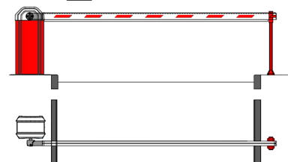
  OUTSIDE LOOKING IN
  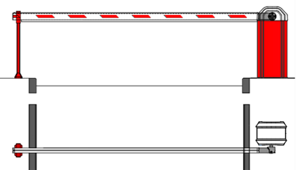
 |  | Section 3A. Which safety device(s) do you require? |  |  |  |  |  |  |  |  |  | Section 3B Master & Slave
 |  | ☐ |  | Dual channel loop detector |  |  |  |  |  |  | ☐ | YES (Barriers need to work in tandem)
 |  | ☐ |  | Photocells battery/hardwired |  |  |  |  |  |  | ☐ | NO (Barriers are independent operation)
 |  | ☐ |  | Radar detector

Section 4. Additional Products Required
End Rest: | Adjustable End Rest |  |  | ☐ | Pogo Stick End Rest — (integrated Pogo with Hi-Bar Skirt) |  |  |  |  | ☐
Signs: | No Entry | ☐ | Entry | ☐ | No Pedestrians | ☐ | Stop Sign |  | ☐ | Lorry Height Stop Sign |  |  | ☐
Signs: | No Exit | ☐ | Exit | ☐ | Miles Per Hour | ☐ | Please Specify Mileage:
Pedestals | Dual Height Reader Pedestal |  |  | ☐ | Lorry Height Reader Pedestal |  |  | ☐ |  | HD Option (larger reader face plate) |  |  | ☐
Pedestals | Car Height Reader Pedestal |  |  | ☐ |  |  |  |  |  | Swan Neck Option |  |  | ☐
Additional Items | Barrier Arm Lights (LED Strip Red/Green) |  |  |  | ☐ | Magnetic Arm Lock |  | ☐ |  | UPS Battery Backup |  |  | ☐

Section 5: Product Colours - Please select you preferred colours
☐ | Red Cabinet - RAL 3020 - Red/White Arm |  | 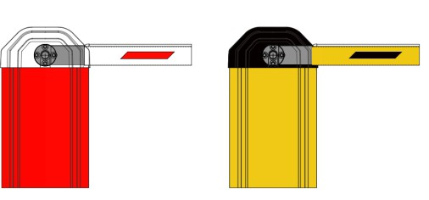 | Please complete this section in full as it denotes that you have filled out the form with the correct information for us to manufacture your product.  ease note failure to do this will affect the progress of your order.  First Fence cannot be held responsible for inaccuracies in the information you provide. Please sign to confirm that this information is suitable for manufacture
☐ | Yellow Cabinet - RAL 1003 - Yellow/Black Arm
Non Standard Colour + RAL

Section 6. Delivery or Install Address / Collection (Any specific requirements for delivery vehicle?)
Required By Date | Delivery Address | Tail Lift Delivery Required? | ☐
Changes: (FFL INTERNAL USE ONLY)

Print Name | Company Name | Signature

