Document Ref: |  | SAL009 - FF5000-21 Manual Barrier Handing Form
Customer Information
Quote Ref: |  |  | Customer Contact Number:
Thank you for choosing First Fence Ltd.
Please use the checkboxes (☐) below to select your required product and complete all relevant sections of the form.
Once completed, please save as a .PDF document and ensure the form is signed electronically, then return it to us via email.
Section 1. Barrier Type and Additional Information |  |  | Section 1B. Pole Length & Additional Features
 |  |  | Pole Length = |  | mm
Section 1A. What type of Manual Barrier do you require? |  |  | Plain Pole |  | ☐
☐ | 5000-21 - STD Manual Raise Arm Barrier  up to 7.0m Plain Pole / Bottom Skirt = 6.0m |  | Bottom Skirt |  | ☐
☐ | 5000-21 - HD Manual Raise Arm Barrier  up to 9.0m Plain Pole / Bottom Skirt = 8.0m

Section 2. Barrier Handing - View from outside of the site looking in
☐ | Tick For Right Handed | ☐ | Tick for Left Handed
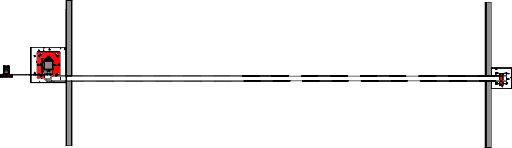 |  | 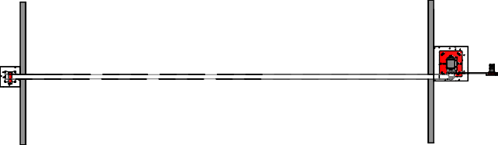
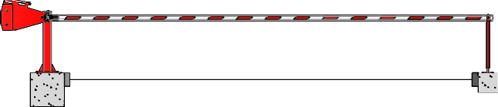 |  | 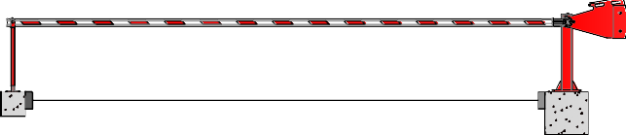
OUTSIDE LOOKING IN |  | OUTSIDE LOOKING IN

Section 3. Additional Products Required
End Rest: | Lockable End Rest  Included as standard |  |  | ☐ | Pogo Stick End Rest — (integrated Pogo With Skirt) |  |  | ☐
Signs: | No Entry | ☐ | Entry | ☐ | No Pedestrians | ☐ | Stop Sign | ☐ | Lorry Height Stop Sign |  |  | ☐
Signs: | No Exit | ☐ | Exit | ☐ | Miles Per Hour | ☐ | Please Specify Mileage

Section 4: Product Colours - Please select your preferred colour(s).
☐ | Red Cabinet - RAL 3020 - Red/White Arm |  | 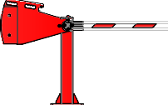 |  | 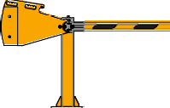 | Please complete this section in full as it denotes that you have filled out the form with the correct information for us to manufacture your product.  ease note failure to do this will affect the progress of your order.  First Fence cannot be held responsible for inaccuracies in the information you provide. Please sign to confirm that this information is suitable for manufacture
☐ | Yellow Cabinet - RAL 1003 - Yellow/Black Arm
Non Standard Colour + RAL

Section 5. Delivery or Install Address / Collection (Any specific requirements for delivery vehicle?)
Required By Date | Delivery Address | Tail Lift Delivery Required? | ☐

Print Name | Company Name | Signature

